Report
Field | Detail
Team ID | Individual
Project Name | Smartphone Usage, Digital Addiction & Well-Being Analytics
Maximum Marks | 5 Marks
A report is a comprehensive document that provides a detailed and structured account of data analysis, findings, and insights. It is typically used for in-depth analysis, documentation, and communication of results. Reports are suitable for a diverse audience, including decision-makers, analysts, and stakeholders who need a comprehensive understanding of the data.
Designing a report in Power BI involves connecting to data sources, creating visualizations like charts and graphs, customizing their appearance and interactivity, organizing them logically on the canvas, formatting elements for consistency and clarity, and optionally creating dashboards for a summarized view. Throughout the process, it's essential to consider the audience's needs and ensure the report effectively communicates insights from the data. Finally, iterate based on feedback to continually improve the report's design and usefulness.
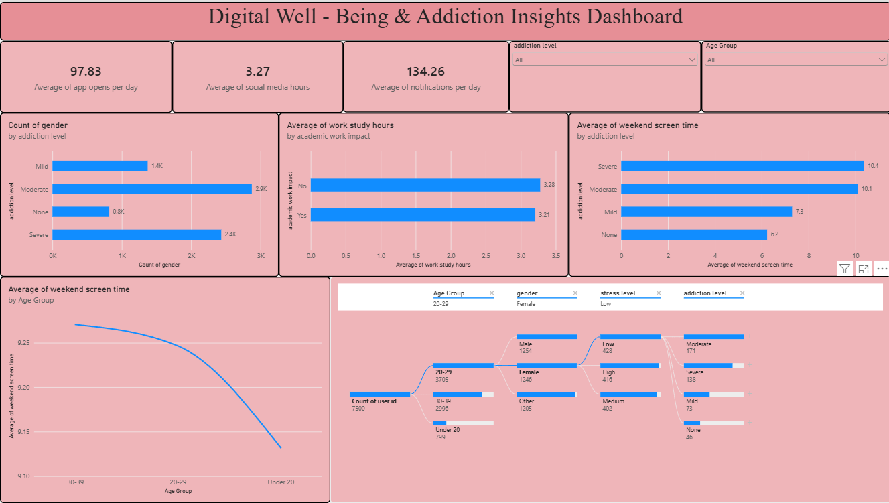
User Smartphone Behaviour Analysis
Observations drawn from reports in Power BI can provide valuable insights into behavioural performance and digital addiction trends.
1. Trends Over Time
- Analyze how key metrics (e.g., screen time hours, app open frequency, or notification counts) shift across weekend periods versus weekdays to identify escape behaviours or user dependency shifts.
2. Performance Comparisons
- Compare digital behaviour across different tracking features, such as entertainment consumption (social media/gaming) vs. functional work/study allocations, to evaluate user priorities and time management.
3. User Segmentation
- Assess demographic data (age, gender, location tracking metrics) to understand vulnerable user segments and tailor highly personalized digital detoxification strategies accordingly.
4. Goal Achievement
- Measure progress against established health and well-being KPIs (Key Performance Indicators)—such as keeping baseline stress levels low and maintaining sufficient sleep duration hours—to assess whether behavioural moderation goals are being met.
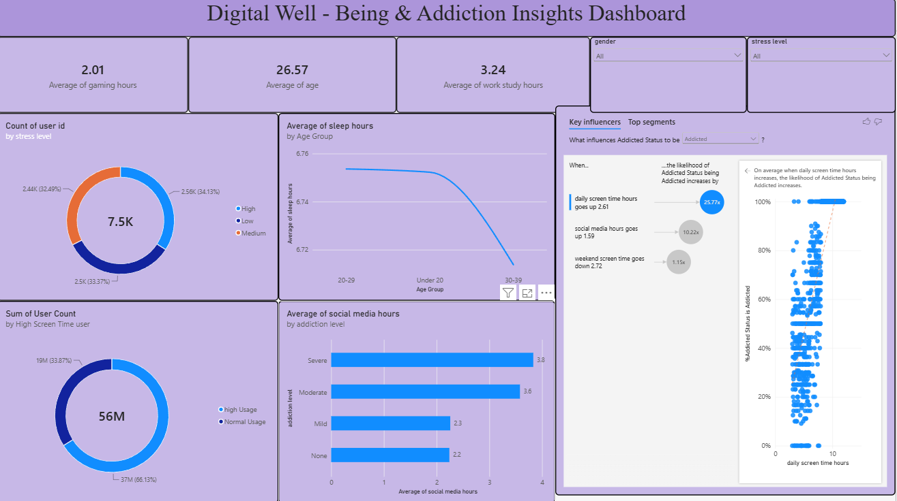
Example Dataset Analytics Insights
1. Gender Distribution
- The gender distribution chart indicates that tracking logs differ noticeably, showing that more phone records are compiled from males (425,601 logs) compared to females (247,174 logs) within the target data group.
2. Age Group Analysis
- Among the monitored profiles, the youth category (under 21) has the highest representation at 464,000 baseline rows, indicating a significant concentration of young device users. This metric emphasizes the critical need for built-in application restrictions, customized screen-time limits, and health warnings tailored for this younger age group.
3. Regional Lifestyle Disparities
- The High Stress segment shows the poorest physiological balance, responsible for a peak sum of 59,888 sleep deprivation flags linked to high late-night activity. Addressing these screen habits during restorative evening hours could systematically improve rest success metrics.
4. High Dependency Overview
- A cumulative total of 706,000 tracking logs have been successfully processed, indicating major device usage thresholds across the entire cohort. Sub-cohort sections displaying maximum screen surges (e.g., users logging up to 162,407 extreme hours) should be prioritised for immediate screen-time notification limit intervention.

